**HEALTH LESSON #3**

**POISONS**

**Hi Everyone,**

**Hope you are doing well. Here are the correct answers for last week’s questions on “Caffeine”**

* 1. **Does most chocolate have caffeine in it? - YES**
  2. **Caffeine could make you sleepy- NO**
  3. **Caffeine could raise my heart rate- YES**

**__________________________________________________________**

**Today we will be talking about “POISONS”. What is a poison? A poison is a substance that causes harm to you when it enters the body or touches the skin.**

**There are several things in your house that could be poisonous. DO NOT TOUCH THEM!!!! Ask an adult if you are not sure if something is a poison. Poisons can be found in several places in your home such as the bathroom, kitchen, garage, yard etc.**

**Here are some pictures of poisons that could be found in your home:**

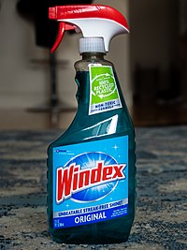 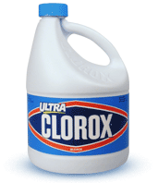

**glass cleaner bleach**

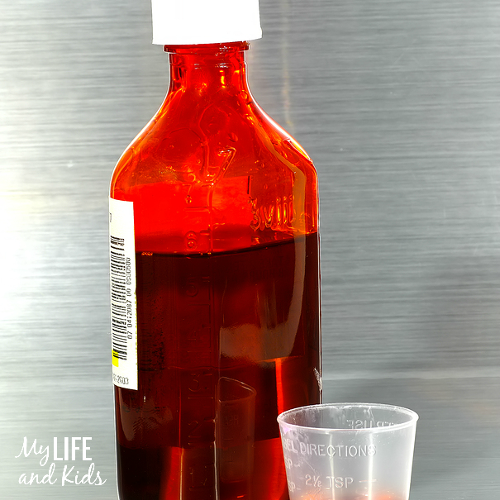 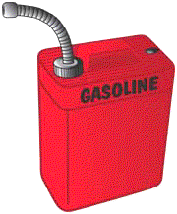

**medicines gasoline**

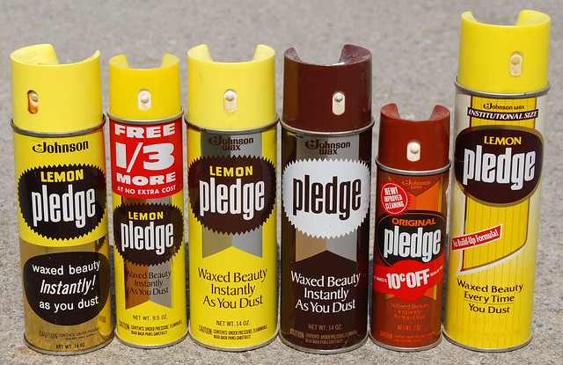 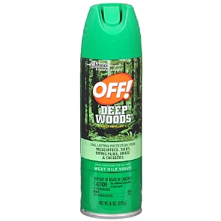

**furniture polish bug spray**

**These are just a few examples of Poisons. Please watch the following video about Poisons. Our danger ranger friends help us to learn about “Poison Safety” in this episode.**

* 1. **Please go to YouTube.com**
  2. **Please type in danger rangers Chem Gems**
  3. **Please click on the Video titled, “Chem Gems”**
  4. **Please watch video!**

**\*\*\*FAMILIES: IF YOU CAN, PLEASE SEND A CONFIRMATION EMAIL TO US THAT YOU COMPLETED THE ASSIGNMENT FOR CREDIT**

**If your health teacher is Mrs. Miller send email with the name of the student to:** [**MillerA@dvsd.org**](mailto:MillerA@dvsd.org)

**If your health teacher is Mr. Feiss send email with the name of the student to:** [**FeissJ@dvsd.org**](mailto:FeissJ@dvsd.org)

**Take Care and talk to you soon,** 

**Mrs. Miller & Mr. Feiss**